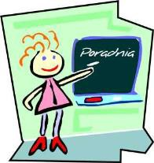

SPECJALISTYCZNA PORADNIA PSYCHOLOGICZNO - PEDAGOGICZNA DLA DZIECI Z NIEPOWODZENIAMI EDUKACYJNYMI W KRAKOWIE (SPECIALIST PSYCHOLOGICAL AND PEDAGOGICAL COUNSELING CENTER FOR CHILDREN WITH EDUCATIONAL FAILURES)
ul. ŚW. Gertrudy 2
Phone: 12 422 43 83; 660 637 312; pppddd@op.pl; www.poradnia-psychologiczna.com

I consent that my child comes back home on his/her own
………………………………………………………………………………………………….. After the examination in this Center on ……………………………………………………........ I take full responsibility for his/her life and health

…………… ……………………….
Kraków, date Parent's or legal guardian's signature

